Doña Ana (Doña Ana County Health & Human Services) PDO 2021

Demographic & Post Test: https://tinyurl.com/DADemoPost21
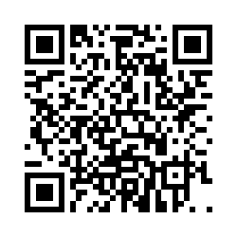

Record of Use: https://tinyurl.com/ROU-DA21
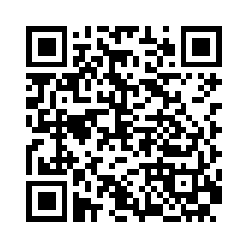

Follow Up: https://tinyurl.com/DAFollowUp21
